Analysis of Social Network Simulation

Reece Jones

Notation

number of people in a network.

probability of a person liking an interactable post.

probability of a person following the creator of a liked post.

set of all people in a network.

person , where .

set of creators of posts .

set of all posts in a network.

set of posts made by person .

set of people person is following.

set of people selected by simulation to be followed by person .

set of posts liked by person .

set of posts selected by simulation to be liked by person .

set of interactable posts for person .

network parameter after timestep . .  
 represents the state before simulation begins.  
 represents the state after the simulation has completed.

random subset of , where each element has probability of being included.

Simulation model

The simulation is based on a social media network consisting of people and posts made by those people. Each person may *follow* zero or more other people and may *like* zero or more posts, forming connections within the network. The simulation models the evolution of these connections through time. The flow of time in the network model is quantised into *timesteps*. At each timestep, the evolution algorithm is applied, producing a (typically) new network structure.

The algorithm iterates the people in the network and possibly causes them to form new connections to other people and posts. For each person, a set of “interactable” posts () is generated, consisting of posts made and liked by people that person is following. This emulates the behaviour of a real social media application, in which one typically is shown a list of posts/activities from connected people.  
For each interactable post, there is a chance for the person to like the post (), and if liked, a chance for the person to follow the creator of the post (). (An additional like chance scaling factor may be present for a specific post, however this will be ignored in this analysis for simplicity.) These probabilities are constant parameters of the simulation.  
The simulation can be represented mathematically as:

The network is typically seeded with set values of , , and , with further changes to the network made only by the simulation algorithm.

The simulation is considered complete when each person likes every post they possibly can and follows every person they possibly can via simulation alone. Note that this is dependent on the initial network structure and is not the same as a fully connected graph; see the code and documentation for details.

Computational complexity of simulation

The simulation code has been developed and optimised for performance. The time complexity of basic network operations are as follows:

* Iterating :
* Iterating :
* Iterating :
* Iterating :
* For a person , checking :
* For a post , checking :
* Adding a person to :
* Adding a post to :
* Finding the creator of a post:

(A complete explanation of the code is available in the documentation, from which the time complexities may be derived.)

Then the time complexity for evaluating timestep is:

That is, proportional to the number of total number of interactable posts across all people. However, the values of and vary throughout simulation and are heavily dependent on the network structure. The following sections will examine the behaviour for certain structures.

Randomised network structure

In this network, each person follows a random number of randomly selected people and has a random number of posts. The number of follows and posts per person are normally distributed with . People to be followed are chosen by simple random sample (without replacement).

To calculate the time complexity of simulating one timestep, we approximate the number of follows and post likes for any person at some timestep as uniformly distributed:

And approximate the number of posts for any person as uniformly distributed:

Then the time complexity of timestep is approximately:

In order to calculate the time complexity for the entire simulation, we must evaluate and at each timestep, as well as calculate the total number of timesteps before completion.

In each timestep, and may not be disjoint, nor and ; that is, follows and likes acquired through simulation may already be present. Note that , therefore we expect to contain posts already in . For , we estimate that the proportion are already in (a better approximation likely exists, but I was unable to derive it).

Then the increase in follows and likes from timestep to is approximated by:

Since is sampled uniformly from :

Calculating the value of is more difficult, since and may not be equal if there exists . The creators of all posts in the network may be considered a multiset, with multiplicity of each element approximately . Notably, if selecting a post creator at random, the probabilities of selecting each are approximately equal.  
In general, when selecting a random sample of size from a sequence of distinct items with replacement, where each distinct item has an equal probability of being selected, the expected number of unique values is given by (**citation needed**). Thus:

The approximation of similarly requires adjustment for repetition of posts:

The simulation will be complete when and for all . For large , for which the network is likely to be a connected graph, we may approximate:

Substituting equations 3, 6, 7, and 8 into 5 yields the recurrence relation

with initial conditions and . Unfortunately converting these relations into exact formulas for and is non-trivial, and is left as an exercise for the reader.  
However, basic observations may still be drawn by evaluating the relations and comparing them with real simulation data. The following data was gathered for and . Simulation completion for the mathematical prediction was approximated by and .

Figures 1a and 1b plot and over each timestep, for the mathematical prediction and real simulation, respectively. These values exhibit exponential growth resisted by a limiting factor, which aligns with an intuitive expectation of the simulation’s behaviour: the number of new connections per timestep is proportional to the number of existing connections, however is limited by the size of the network. Equations 9a and 9b have resemblance to the logistic equation, a model of population growth (**citation needed**). Note that typically lags by an amount scaling with , as a post must be liked first before the associated follow can be made.

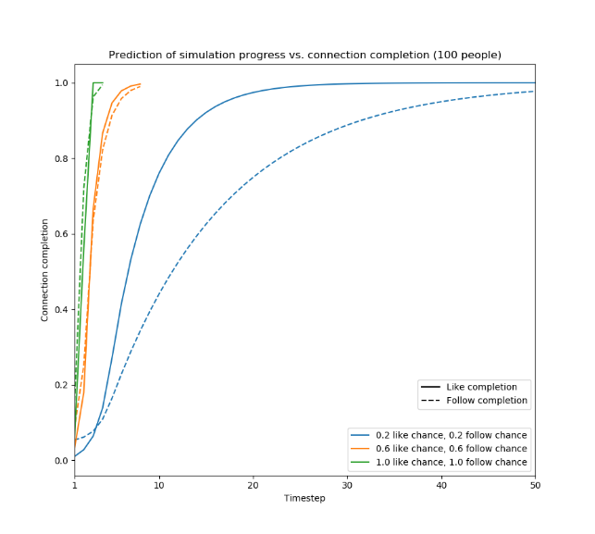

Figure 1a: simulation progress vs. connection completion, using the mathematical prediction for a random network with N=100.

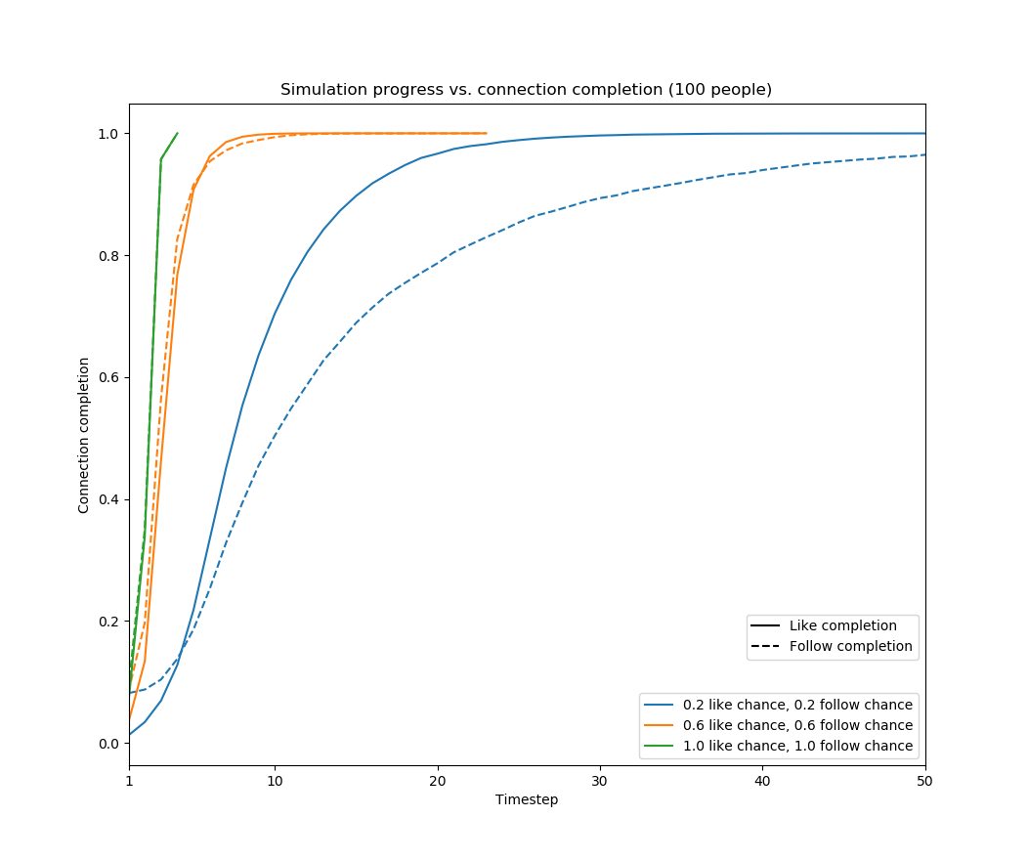

Figure b: simulation progress vs. connection completion for a random network with N=100.

Figures 2a and 2b show the predicted and actual computational time required for evaluating a timestep over the course of a simulation. As expected, the computational time is seen to be approximately proportional to the connection completion, which is approximately proportional to the total number of interactable posts. Note that the maximum actual computation time per timestep is not the same for different like and follow chances, whereas in the prediction they are equal. This is due to the use of Big-O analysis for the prediction, which ignores constant factors. (In the simulation, lower and equate to fewer operations overall, resulting in a difference by a constant factor).

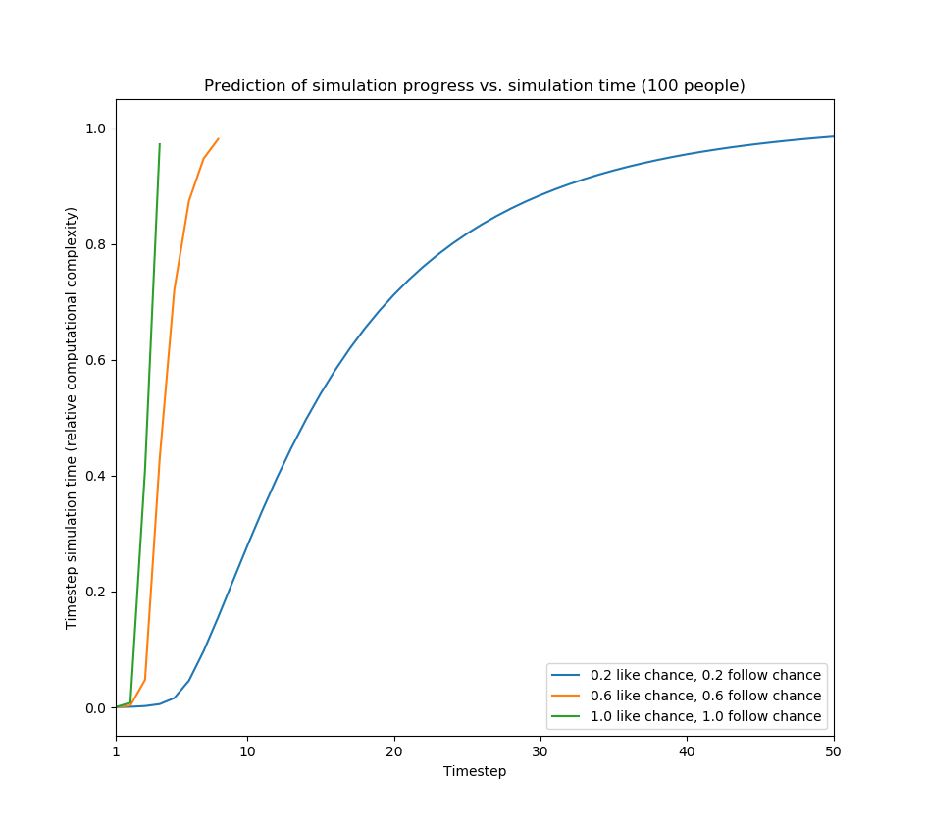

Figure 2a: simulation progress vs. relative timestep time complexity using the mathematical prediction of a random network of N=100.

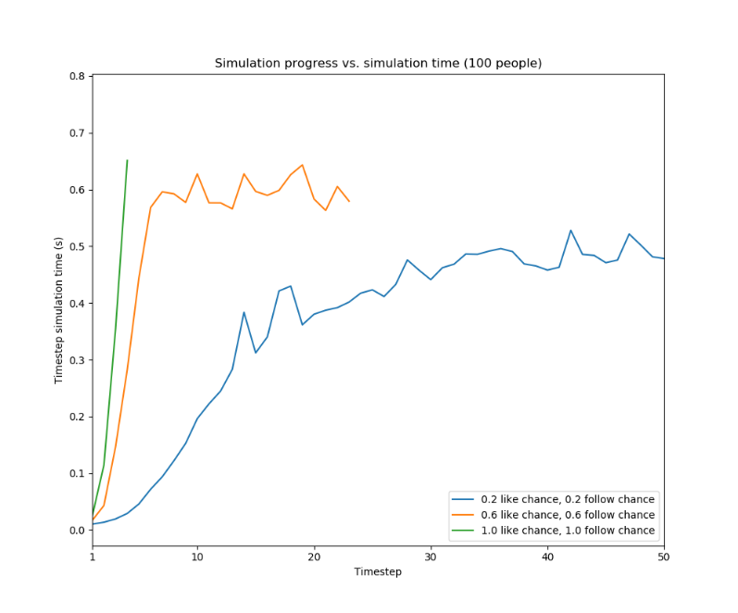

Figure b: simulation progress vs. timestep evaluation time for a random network with N=100.

Figures 3a and 3b show against the number of timesteps to achieve and . The mathematical approximation predicts what seems to be logarithmic growth, while the simulation shows more linear growth for low and . More data is needed to make an exact conclusion, however growth less than linear intuitively seems likely for a random network, as distance of the shortest path between any two people, and thus the maximum number of timesteps for a post to become directly connected, is likely be to much less than .

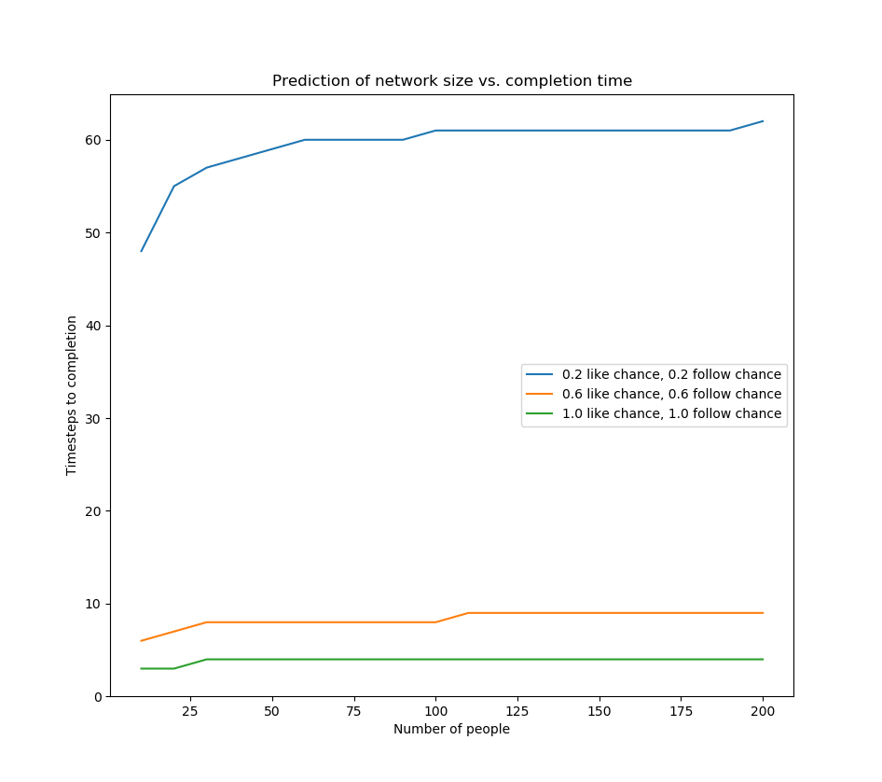

Figure a: network size vs. timesteps to completion, using the mathematical prediction of a random network.

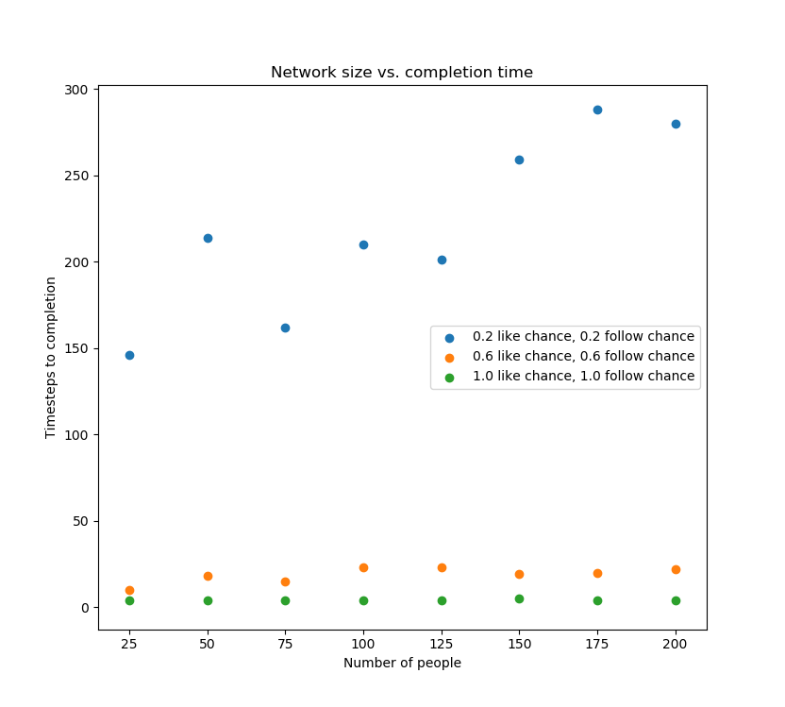

Figure 3b: network size vs. timesteps to completion for a random network.

Overall, the mathematical approximation analyses the measured results decently, but with definite flaws. Most notably, it cannot be used to accurately predict the timestep at which the simulation is completed; due to its unquantized, asymptotic nature, neither nor reach 1, whereas such a state does occur in the real simulation. Additionally, its behaviour in the first few timesteps is inaccurate, as can be seen in figures 1 and 2, particularly when and are low. Finally, the predicted appears to lag slightly too much, as seen in figure 1. Improvement of the prediction and elimination of these flaws is likely possible with a more advanced and rigorous analysis of the structure of the random network.

Linear network structure

In this network, the set of follows resembles a linear graph, with the first person having one post. More precisely:

for

for

Such an example is unlikely to occur in a real social network, yet I wish to examine it in contrast to the random network to demonstrate the effect of network structure. I have not derived a mathematical solution to this network type as it proved to be too difficult; therefore, this section will give only a general, surficial analysis of the simulation.

The most notable feature of this network structure, unsurprisingly, is its linearity. With only one initial follow per person, “depends” directly on , and. Therefore, it will take at minimum timesteps before and and the simulation is complete; i.e. linearly proportional . Figure 4 illustrates this relationship. In comparison with the random network, a significantly larger amount of timesteps required to complete a simulation.

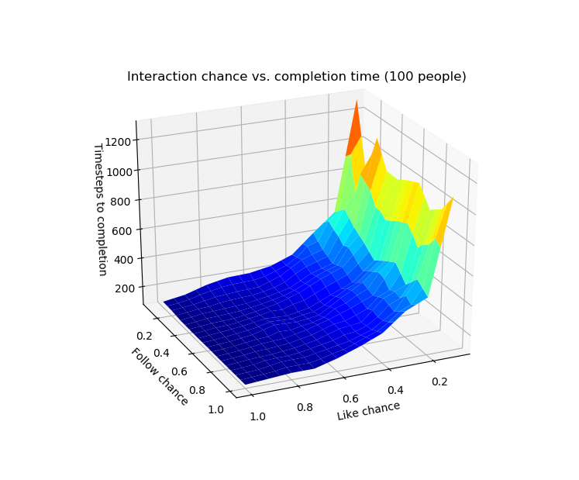

Figure 5: P(L) and P(F) vs. timesteps to completion for a linear network with N=100 (linearly interpolated surface).

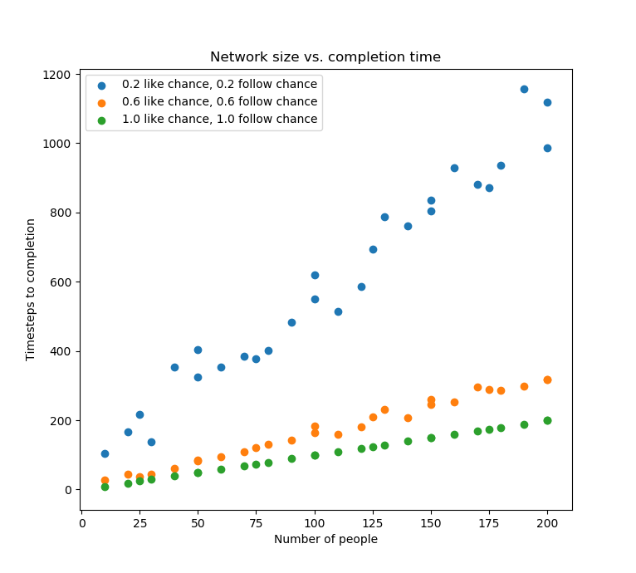

Figure 4: network size vs. timesteps to completion for a linear network.

Since is proportional to , and to , the number of timesteps to completion is also inversely proportional to and . Figures 5 shows this relationship. Note that does not seem to have a particularly large effect on the completion time, except perhaps for very low values. A plausible explanation for this is that most of the time is spent “waiting” for , which takes time proportional to and , after which takes time proportional only to .

However, despite many timesteps being required for completion of a simulation, each timestep is evaluated quickly, as shown in figure 6. Since , , and are either 0 or 1, evaluating a timestep has a time complexity of . Similarly to figure 2b, the real time taken still depends on and , as they influence the number of other operations. Note also that the measured times are likely subject to relatively high error due to the small values, as can be seen with the outliers for and around .

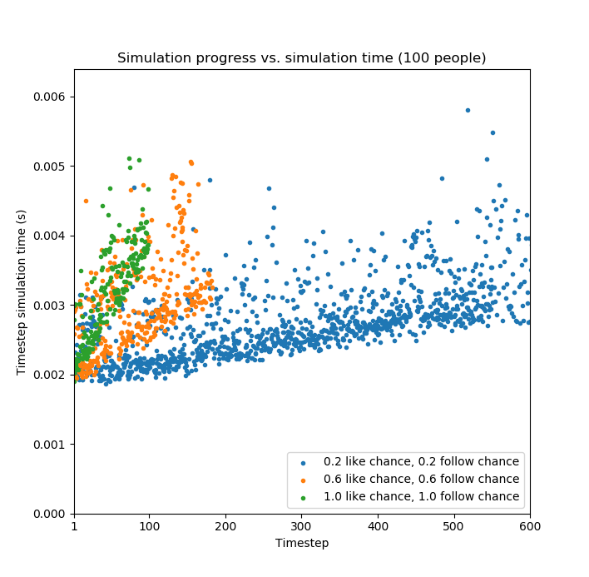

Figure 6: simulation progress vs. timestep evaluation time, for a linear network with N=100.

References

<https://math.stackexchange.com/questions/1386527/expected-amount-of-repeats-in-a-random-sequence-of-integers>

<http://mathworld.wolfram.com/LogisticEquation.html>